Pre-Production Design & Development Plan

Project Overview

Working Title
Parcel Panic!

Game Summary
The player runs a packing and shipping store where they receive orders containing specific packing requirements. Each item must be prepared by going through a series of interactive packing games, with the quality of the completed package deciding the reward. These tasks are designed with maximising the platform in mind, taking advantage of things like tilt as well as touch and drag while understanding the limitations.

At the end of each day the player can use these profits to upgrade the store by purchasing more order requirements and packing options. As the store gets upgraded, orders become more demanding while providing a higher ceiling for rewards, creating a progression loop designed to encourage the player to improve their efficiency and accuracy.

Genre
Management sim/Mini-games

Target Platform & Orientation
- Platform: Android
- Device: Mobile phone
- Orientation: Landscape

Target Audience
This game is targeted towards casual mobile players who enjoy simulation and task based experiences. Little previous experience is needed, this is because the packing tasks are designed to be introduced gradually during the play session and only consist of basic touch-based interactions.

Gameplay is structured around short and pressured work sessions where the play is required to complete a number of orders before the end of each day without making significant mistakes. This establishes a balance between needing to be accurate and needing to be quick which the player must maintain.

The game is intended to be accessible with clear objectives, simple interactions and a gradual increase in difficulty, while giving the player added depth through progression, time pressure and optimisation. Play sessions for each in game day are targeted towards 5-10 minutes and for an entire run could go for up to an hour potentially.

Player Experience Goals
Goals:
- Satisfying – Touch, drag and tilt mechanics provide visual, audio as well as haptic feedback after completing tasks.
- Fast paced – Every in game day requires the player to finish a set amount of orders within a limited time frame, which encourages efficient decision making and execution.
- Understanding – Requirements for orders are presented clearly during the packing with visual feedback assisting the player in understanding the needed/correct actions.
- Rewarding – Correctly fulfilled orders generate profits which are used to upgrade the store and packing options.
- Progression – New purchases change the packing options which gradually increases both rewards and complexity.

2 Game Design

2.1 Player Goal
The players goal is to make a profit packing and sending items for clients to a high standards to make the most money possible while completing the daily required packages amount. These profits can be used to upgrade the store increase possible profits as well as difficulty.

2.2 Core Gameplay Loop
- Order received: An item arrives in front of the player, along with an order note which contains the package size, protective materials, amount of tape and the stamps/labels needed.

- Preparing the parcel: The player then goes through the 4 stages of preparation to fulfil the requirements.
- Quality review: The quality of the parcels preparation is then graded by the game and the player receives or loses money reflective of the job they did, any steps which they failed will be a strike for the day.
- Goes back to step 1: The player then receives a new item with new packaging specifications.

2.3 Extended Gameplay Loop

- Day starts
- Process the daily required orders
- Earn money based on performance on that days orders
- Day ends
- Purchase upgrades (if you made enough)
- Games difficulty increases based on what you got
- Back to 1

2.4 Moment-to-Moment Gameplay
- Receive item.
- Read requirements.
- Select appropriate packaging.
- Apply protection.
- Apply required tape.
- Apply stamp/labels.
- Submit package.
- Receive feedback.
- Continue to next order.

3. Core Mechanics

3.1 Order System
The player will receive special order requirements for every item they receive, these requirements will consist of the box size, protective packaging type, amount of tape, and finally stamps/labels. The requirements for an order will be chosen randomly from an array of options, the available options will begin at 1 for all, but as the player upgrades their stations, they will unlock more order options making every parcel preparation different. The specifications will be communicated with text as well as simple visuals indicating what’s needed.

Order Data
Specification | Possible Values
Box size | Small/Medium/Large/Extra Large
Protection | Bubble wrap/ Packing Peanuts/ Styrofoam/ Crumpled Card
Tape | 2 Strips/ 4 Strips/ 6 Strips/ 8 Strips
Stamp/Labels | 1st Class/ Next day/ Fragile/ This Way Up

3.2 Conveyor / Item System
Items appear one by one along the conveyor periodically as the day passes, the frequency of the items appearing depends on how many orders need to be completed on that day. The player must tap on the item on their conveyor, then it will be brought closer alongside it’s order requirements. There will be a tappable button that reads “begin order”, which will take the player with the item to the first packing station to begin preparing it. Each station will have a tappable button which, when pressed, will end the current task and move on the next. When all of the tasks are completed, the game will display how the player did and tell them how much money they made.

3.3 Boxing / Packaging Mechanic

Player action
The player will need to drag a box of the needed size from its section and then tap a number of times to unfold it into a full box ready to place the item in.

Input
This interaction will require the player to press and drag from the correct box size, then take it to the unfolding area in the middle of the screen. The player will then need to tap on the box multiple times to unfold it ready to use for the rest of the order

Success condition
The players success condition is the player picking the box size that is specified on the brief, and fully unfolding it.

Failure condition
The failure condition is any size of box which is not the one specified on the order, and if the player does not entirely unfold the box, both of these will count as a strike for the player that day.

Feedback
- Visual: hen the box is being dragged, it follows along with the player finger as well as becoming highlighted. Every time the box is tapped to unfold, it visually changes state so the player is able to understand that they are making progress.
- Audio: short sound effects will play during each interaction, such as picking up a box, placing it on the unfolding area, the unfolding process and finally when it is done and ready to use.
- Haptic: There will be a light vibration to confirm when the player chooses the correct box size and unfolds it to completion. These haptic features should be optional for the player so these should also be communicated in other ways for accessibility.

3.4 Taping Mechanic

Player action
The player will drag across the box to create lines of tape, the player may put as many lines as they want, but should aim to do the amount which the order specifications request.

Input
The input is a simple tap and drag for each line of tape, the player must start entering one edge of a box and continue until going off the opposite edge.

Success condition
The success condition of the taping is having the same number of tape strips that is specified by the order specifications.

Failure condition
A failure is defined by any amount of tape strips that is not the one on the order specification and will result in a strike, or if the tape does not go across the whole face of the box it will be invalid and will not be placed.

Feedback
- Visual: As the player drags along the tape strip, a greyed out version of the strip will form from where the players press began and to where there finger now is, it will follow this until the player releases it, at which point the coloured version of the tape will appear on the box.
- Audio: There will be a simple motif noise when the player first taps, then there will be tape sfx as the player extends the tape they are putting down, and a final sfx for when the drag is released and the tape is placed.
- Haptic: there will be a light vibration when the player successfully places a strip of tap on the box/when the tap is released.

3.5 Stamp / Label Mechanic

Player action
The player picks out stamps and/or labels from the available selection and drags and drops them onto the package.

Input
The input will only consist of tapping and then dragging to the chosen area on the package.

Success condition
The success condition is that the stamps and/or labels from the order sheet are all added to the package by the player.

Failure condition
A failure will happen when anything but the correct stamps/labels are present on the package when the player submits it.

Feedback
- Visual: When the player chooses a stamp/label, it will appear where the players tap/drag is located and follow it until it is placed at the location of the players choice on the package.
- Audio: There will be a short audio motif when a label/stamp from the options is selected and another when one is placed on the package.
- Haptic: There will be a light vibration when a stamp/label is placed on the package.

4. Package Evaluation
The game will compare how the player prepared the package to the order specifications they received for the item and make sure that they are right.

Evaluation Criteria
Each of the 4 order specifications will be checked for if they were completed correctly, each incorrect section will decrease the money made for that package by 25%, as well as giving the player a strike for the day.

5. Game Structure & Progression

5.1 Session Structure
Main menu → Start day → Complete orders → Upgrade shop → Return to step 2.

5.2 Failure
If the player gets 3 incorrect orders in a single day, the game will end and the player will fail, alternatively if the day ends and the player still has incomplete orders remaining they will lose the game and need to restart to continue playing.

5.3 Success
The only success in the game is completing more days and buying more upgrades for the store, there is no ending and the game is designed to eventually be lost no matter what.

5.4 Difficulty Progression
There will be 2 main forms of difficulty progression present, first, as more days pass the number of orders the player needs to complete with gradually increase which the player must fulfil to progress. Second, as the player buys upgrades, the number of options available on the order specifications will increase, leading to more variety in orders and more opportunities for mistakes to be made.

5.5 Economy / Rewards
Money is earned by the player completing orders, all orders will provide a different amount of money, any errors made during the order will decrease how much the player receives significantly. Money will become available to spend at the end of the day before starting the next.

6. MVP & Scope

6.1 Minimum Viable Product
A list of features that will need to be present for the minimum viable product:
- Playable day
- Receiving orders
- At least 2 packing tasks
- Errors and reduced payment
- Receiving money for completing packages
- Losing
- Touch controls

6.2 Secondary Features
- Full set of order tasks
- Multiple days
- Upgrades
- Difficulty curve
- Haptics

6.3 Stretch Features
- Gyro
- Winning/ending
- More expansive order system
- More business sim elements
- Changeable orientation

7. Mobile-First Design

7.1 Why Mobile?
This game is explicit being designed for touch screen devices because the planned gameplay is fully centred around being apple to tap and drag and short fun interactions which would thrive in the basic pick up and play format of a mobile game.

7.2 Device & Orientation
- Target platform: Android mobile devices.
- Orientation: Landscape.
- Screen assumptions: Typical rectangular mobile displays.
- Typical holding position: One hand holding phone with other hand interacting.
- One-handed/two-handed:

7.3 Touch Target Design
The plan is for the majority of the touch inputs to take place in the centre area of the screen as to account for hand placement, all of the mini games and main actions will take place here. As for buttons, the main menu will have centred buttons, and to transition between stages which will be centre right, the pause/options buttons will be placed at at the top of the screen out of the way to avoid them being pressed unintentionally. All inputs will be designed so that they are a suitable size for pressing with a finger while not being overly large, with the pause/menu button being slightly smaller as to not clutter the screen.

7.4 Accessibility / Usability
Some accessibility features I could consider depending on scope could be:
- Text size
- Colour blind mode
- Language
- Audio + haptic controls
- Visual feedback beyond colour + sound

8. UI/UX Design

8.1 Information Hierarchy
The interface I make will need to prioritise information based on it’s relevancy to the current task at hand in the game. Because the game is built upon a blend of accuracy and time pressure, the information being displayed will need to be easy to identify and understand without being time consuming or distracting to consume.
- Order requirements: The requirements for the ongoing order will need to be immediately visible and apparent to the player. They determine the players actions throughout an order and are necessary for fulfilling orders correctly.
- Current task: The station/item which the player is working at will occupy the main gameplay area, making the players task visually clear. The interactive objects within the tasks will be distinguishable from background/decorative elements.
- Instructions/feedback: Each task will have communicators which guide the player in what they are supposed to be doing in terms of inputs/actions. Feedback confirms successful actions by the player as well as mistakes/punishments. These should be noticable, clear and prominent without getting in the way of more important visual elements.
- Secondary interface elements: Settings/pause controls and other less frequently needed elements shall remain accessible while not occupying more space than they need in the gameplay area.

8.2 Required Screens
- Main menu
- Gameplay screen
- Pause menu
- Day result screen
- Upgrade screen
- Settings menu
- Game over screen

8.3 Initial Wireframes
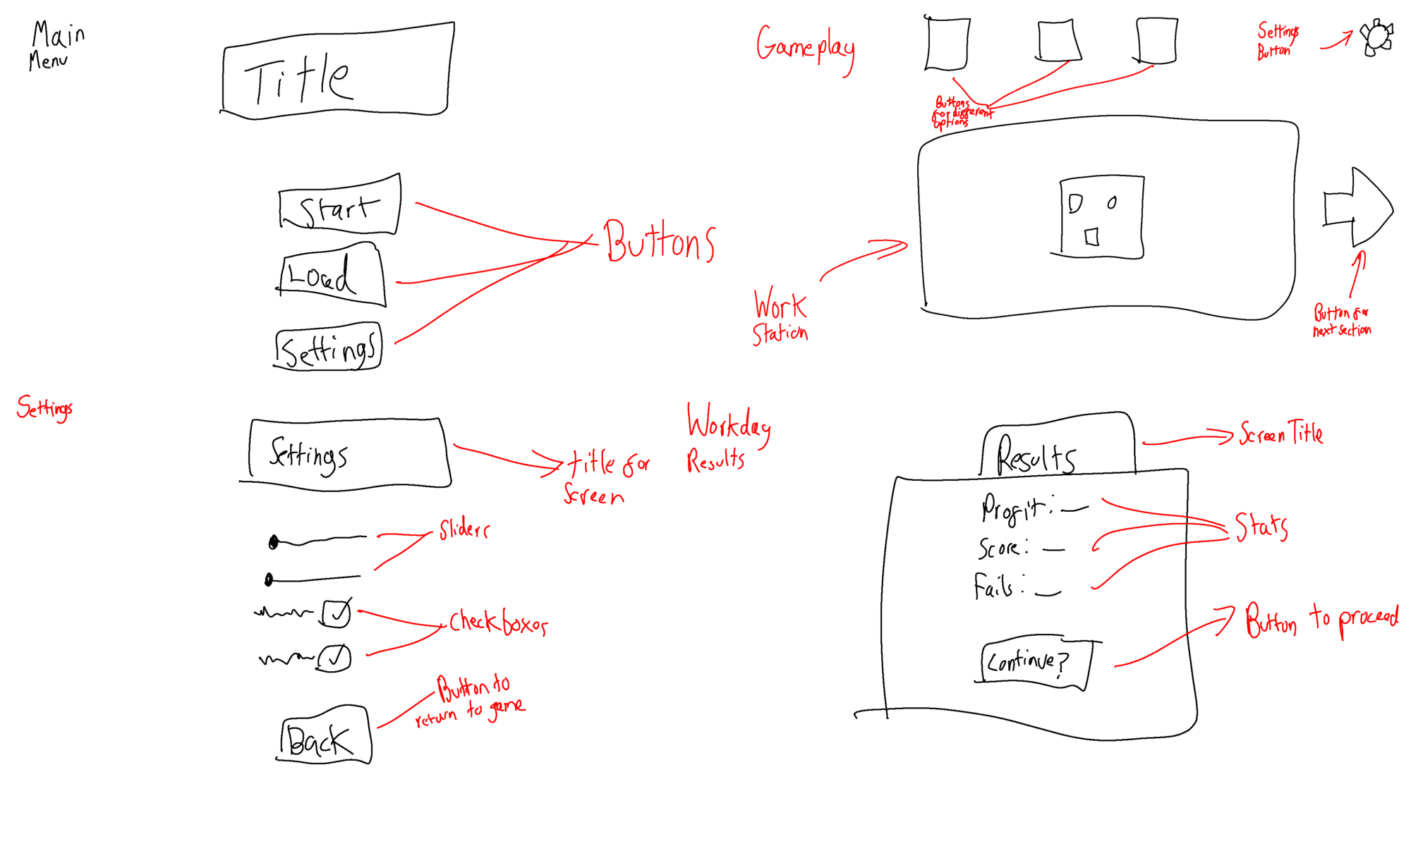

9. Mobile-Specific Feature

9.1 Selected Feature
Haptics

9.2 Why This Feature?
Haptics are going to be used to provide extra feedback to the player and their actions, it will largely be used when the player does an action within the game such as put down a stamp or complete an order.

